|  |
| --- |
| Day-10 Morning Assignment  By  U.Joshna  [04-02-2022] |

|  |
| --- |
| 1.Write the two points discussed about inheritance in the Class?  .Inheritance is the process of re-using base class methods in the  Derived Class  .Inheritance main Goal is : Re-usability  .And to remove Duplicate Code |

|  |
| --- |
| 2.Write example code for:  a.Single inheritance  b.Multi level inheritance |
| Code: |
| using System;  using System.Collections.Generic;  using System.Linq;  using System.Text;  using System.Threading.Tasks;  namespace Single_inheritance  {  class Algebra  {  public int Add(int a,int b)  {  return a + b;  }  public int Sub(int a,int b)  {  return a - b;  }  }  class TotalMaths : Algebra  {  public int mul(int a,int b)  {  return a * b;  }  }  internal class Program  {  static void Main(string[] args)  {  TotalMaths tm = new TotalMaths();  Console.WriteLine(tm.Add(7, 9));  Console.ReadLine();  }  }  } |
| Output: |
|  |
|  |
|  |
|  |

|  |
| --- |
| b.Multiple inheritance |
| Code: |
| using System;  using System.Collections.Generic;  using System.Linq;  using System.Text;  using System.Threading.Tasks;  namespace Multi_level_inheritance  {  class Algebra  {  public int Add(int a, int b)  {  return a + b;  }  public int Sub(int a, int b)  {  return a - b;  }  }  class TotalMaths : Algebra  {  public int mul(int a, int b)  { return a * b; }  }  class AllSubjects : TotalMaths  {  public string Water()  {  return "H20";  }  }  internal class Program  {  static void Main(string[] args)  {  AllSubjects obj = new AllSubjects();  obj.Water();  Console.WriteLine(obj.Water());  Console.ReadLine();  }  }  } |
| Output: |
|  |
|  |
|  |
|  |

|  |
| --- |
| 3.Pictorially represent 3 types of inheritance discussed in the class? |

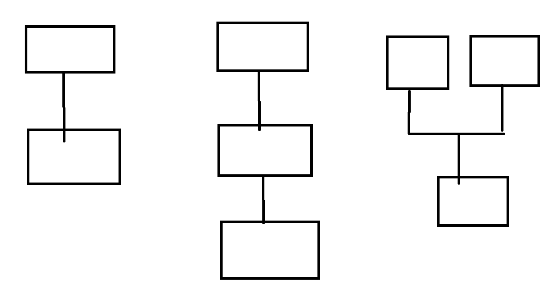

Single inheritance Multi level inheritance Multiple

inheritance

|  |
| --- |
| 4.Why multiple inheritance is not supported for classes in C#  .C# compiler is designed not to support multiple inheritance because it causes ambiguity of methods from different base class.  This is Cause by diamond Shape problems of two classes if two classes B and C inherit from A, and class D inherits from both B and C . so, multiple inheritance is not possible in C# |

|  |
| --- |
| 5.What is Polymorphism?  .Polymorphism is the ability of an object to take on many forms  .it has two types Method Overloading and Method Overriding |